Frameworx Standard

Information Framework (SID)

Common Business Entities – Root Business Entities

Information Framework Suite
GB922 Root
Release 16.5.0
November 2016

Latest Update: Frameworx Release 16.5 | Member Evaluation
Version 16.5.1 | IPR Mode: RAND

Notice
Copyright © TM Forum 2016. All Rights Reserved.

This document and translations of it may be copied and furnished to others, and derivative works that comment on or otherwise explain it or assist in its implementation may be prepared, copied, published, and distributed, in whole or in part, without restriction of any kind, provided that the above copyright notice and this section are included on all such copies and derivative works. However, this document itself may not be modified in any way, including by removing the copyright notice or references to TM FORUM, except as needed for the purpose of developing any document or deliverable produced by a TM FORUM Collaboration Project Team (in which case the rules applicable to copyrights, as set forth in the TM FORUM IPR Policy, must be followed) or as required to translate it into languages other than English.

The limited permissions granted above are perpetual and will not be revoked by TM FORUM or its successors or assigns.

This document and the information contained herein is provided on an "AS IS" basis and TM FORUM DISCLAIMS ALL WARRANTIES, EXPRESS OR IMPLIED, INCLUDING BUT NOT LIMITED TO ANY WARRANTY THAT THE USE OF THE INFORMATION HEREIN WILL NOT INFRINGE ANY OWNERSHIP RIGHTS OR ANY IMPLIED WARRANTIES OF MERCHANTABILITY OR FITNESS FOR A PARTICULAR PURPOSE.

Direct inquiries to the TM Forum office:

240 Headquarters Plaza,
East Tower – 10th Floor,
Morristown, NJ 07960 USA
Tel No. +1 973 944 5100
Fax No. +1 973 944 5110
TM Forum Web Page: www.tmforum.org

Table of Contents
Notice 2
Table of Contents 3
List of Figures 5
1. Common Business Entities – Root Business Entities 7
1.1. Introduction 7
1.2. RootEntity 8
1.3. Entity 9
1.3.1. Entity Overview 9
1.3.2. ManagedEntity Overview 10
1.4. Entity Specification 12
1.5. Role 16
1.5.1. Role Overview 16
1.5.2. Different Types of Roles in the SID 19
1.6. RoleSpecification 19
1.6.1. RoleSpecification Overview 20
1.7. EntityRole 21
1.8. ManagementDomain 22
1.9. ManagementInfo 23
1.10. ManagementMethodEntity 24
1.11. Identification 25
1.11.1. Identification Overview 25
1.11.2. PartyIdentification Overview 25
1.11.3. EntityIdentificationSpecification 27
1.11.4. EntityIdentification 34
1.12. Additional Entity Identification Examples 35
1.12.1. Customer Site Format 35
1.12.2. Equipment Entity Identification Format 37
1.13. Root Business Entities/Characteristic ABE 42
1.14. Policy 63
1.15. Entity Specification Attachment 63
1.15.1. EntitySpecificationAttachment 64
1.15.2. EntitySpecificationDocumentation 65
1.15.3. EntitySpecificationImage 65
1.16. Entity Specification Action ABE 65
1.16.1. EntitySpecificationAction 66
1.16.2. EntitySpecificationActionWorkflow 66
1.17. External System Capability ABE 67
1.17.1. ExternalSystemCapability 67
1.17.2. FulfilmentCapabilitySpecification 68
1.17.3. ChargingCapabilitySpecification 68
1.17.4. BillingCapabilitySpecification 68
1.17.5. PolicyCapabilitySpecification 69
1.17.6. AssuranceCapabilitySpecification 69
1.17.7. Example – Location API offer 69
2. References 78
3. Administrative Appendix 81
3.1. About this document 81
3.2. Document History 81
3.2.1. Version History 81
3.2.2. Release History 83
3.3. Acknowledgments 84

List of Figures
Figure R.02 – View of the Entity Class Hierarchy 9
Figure R.03 - View of ManagedEntities 10
Figure R.01 - ManagementInformation and Methods for Obtaining Management Data 11
Figure R.05 - View of the EntitySpecification Class Hierarchy 12
Figure R.06 - The EntitySpecification – Entity Pattern 13
Figure R.07 - EntitySpecificationType Inheritance 14
Figure R.08 - Interaction Between EntitySpecification and Entity Classes 15
Figure R.09 - The Basics of Roles – An Example 18
Figure R.10 - Associating EntityRoles with an Entity 21
Figure R.11 - ManagementInfo Class Hierarchy 23
Figure R.12 - ManagementMethodEntity Class Hierarchy 24
Figure EI.01. - PartyIdentification Excerpt (taken from Party addendum) 26
Figure EI.02 - Beginning of the Entity Identification ABE Model 27
Figure EI.03 - The Composite Pattern Applied to EntityIdentificationSpecification 28
Figure EI.04 - EntityIdentificationSpecification Examples 29
Figure EI.05 - The EntityIdentificationSpecificationFormat Association Class 30
Figure EI.06 - Identifying Entities Using an Associated EntitySpecification 31
Figure EI.07 - Identifying Entities Using the RootEntityType Entity 32
Figure EI.08 - Use of an Entity Identification Specification 33
Figure EI.09 - EntitySpecification Association With EntityIdentificationSpecification 34
Figure EI.10 - Entity and Entity Identification 35
Figure EI.11 - EntityIdentificationSpec Example 40
Figure EI.12 - Additional EntityIdentification Examples 41
Figure Ch.01 - Characteristic Specification 45
Figure Ch.02 - Characteristic Value 48
Figure Ch.03 - Characteristic Spec Instance – Example 1 50
Figure Ch.04 - Characteristic Spec Instance – Example 2 51
Figure Ch.05 - Content Characteristic Specs 53
Figure Ch.06 - Updated Characteristic Use Entities 54
Figure Ch.07 - Characteristic Specs and Pricing 55
Figure Ch.08 - Content Charging Offer Price 56
Figure Ch.09 - Complex Content Charging Offer Price 57
Figure Ch.10 - Content Charging Product Offer Example 58
Figure Ch.11 - Characteristic Value and Pricing 59
Figure Ch.12 - Content Charging Product Price 61
Figure Ch.13 - Content Charging Usage Specification Example 62
Figure ESAT.01 – View of Entity Specification Attachment 64
Figure ESAA.01 – View of Entity Specification Action 66
Figure ESC.01 – View of External System Capability 68
Figure ESC.02 – External System Capabilities to build a location API offering 70

Common Business Entities – Root Business Entities

Introduction
This guide book defines a set of common business entities that serve as the foundation, and in some cases a root, for certain Aggregate Business Entities (ABEs), specifically Service Specification, Service, Resource Specification, Resource, Policy, PLA Spec, and some Enterprise Security ABEs. It also describes a pattern, called the CharacteristicSpecification/CharacteristicValue pattern that can be used to dynamically define attributes for any business entity.
There are four main motivations for presenting a rooted view of business concepts. First, during our analysis of business-oriented use cases, we often find that certain characteristics and behavior are common across a number of business entities. The SID information model divides the managed environment into eight different management domains. Unfortunately, common characteristics and behavior are often independent of any one particular domain, much less an ABE that first defines the concept. Thus, the first two motivations are:
- To be able to reuse and share the definition of common characteristics where desired, such as the ABEs mentioned above
- To ensure that multiple incompatible definitions of the same concept or entity are not created where desired such as the ABEs mentioned above.

RootEntity
This is the top of the SID class hierarchy. The purpose of the RootEntity is to define a set of attributes that are common to select SID entities in the Service and Resource domains, such as Service, Service Specification, Resource, and Resource Specification, as well as Policy entities in the Common Business Entities domain. These properties enable us to name and describe all objects (manageable and unmanageable) in the environment. It is shown in Figure R.01 below Figure R.01 - View of the RootEntity Class.
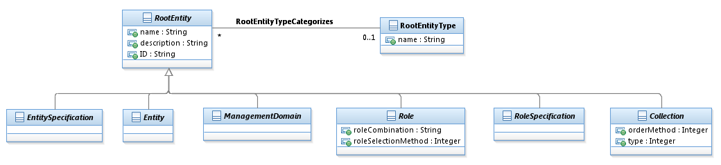
Figure R.01 - View of the RootEntity Class
Note that all five classes shown in Figure R.01 are abstract. This is because they are all conceptual in nature, and exist in order to organize information and concepts. The name attribute is a generic attribute that enables users of the SID to refer to an object using terminology defined by their application-specific needs. The description attribute is an optional attribute that enables users of the SID to customize the description of a SID object. The ID attribute provides a unique identity to each entity.
The following subsections will expand on each of the subclasses of RootEntity, except for Collection. Collection represents collections of ManagedEntity objects. This enables common attributes and relationships and other semantics to be applied to different types of Collections of ManagedEntity objects. These can then be refined in the subclasses of Collection. It is currently only used in the Policy ABE (PolicyRepository and PolicyEventBase) and the Logical Resource ABE (ReplacementSet).

Entity
This section describes the two main Entity classes (Entity and ManagedEntity).

Entity Overview
This is an abstract class that extends the RootEntity class in order to represent classes of objects that play a business function and that may be managed. The top-level Entity class hierarchy is shown in Figure R.02 – View of the Entity Class Hierarchy below.
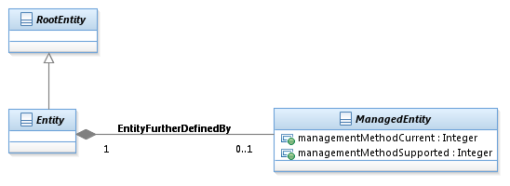
Figure R.02 – View of the Entity Class Hierarchy
ManagedEntity further defines Entity by providing the two attributes and the associations ManagedEntity has with other entities. This allows an instance any entity that inherits from Entity to be defined as a being managed by creating an instance of an association to an instance of ManagedEntity.
ManagedEntity does not itself inherit from RootEntity for the following reasons:
- If it inherits from RootEntity then it further defines Entity by duplicating the three attributes that are already in Entity (that it inherits from RootEntity).
- The composition association between Entity and ManagedEntity with its 0,1 multiplicity is what is often called an “IsA” association, which is much like sub-classing. So if ManagedEntity inherits from RootEntity then it is inheriting attributes it already “inherits” from Entity via the “IsA”.
ManagedEntity is further described in the next section.

ManagedEntity Overview
ManagedEntity is shown in Figure R.03 - View of ManagedEntities is an abstract class in order to represent entities in a managed environment that have the following semantics in common: (1) a business entity owns or is otherwise responsible for them, (2) management of the entity is critical for maintaining the environment, and (3) the entity is “important” from both a business as well as a management point-of-view. As such, ManagedEntity is a point at which semantically important relationships can be created.
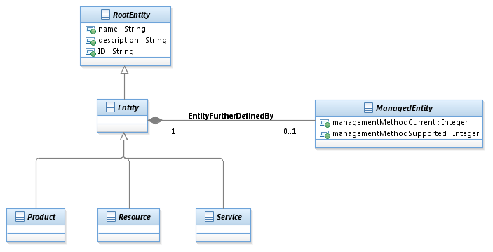
Figure R.03 - View of ManagedEntities
ManagedEntity defines two attributes. The set of different management methods (e.g., using CLI or SNMP, or even using Web Services) that can be used to manage an Entity is contained in the managementMethodSupported attribute, while the current management method that is being used is contained in the managementMethodCurrent enumerated attribute. This is shown in Figure R.04 - ManagementInformation and Methods for Obtaining Management Data below.

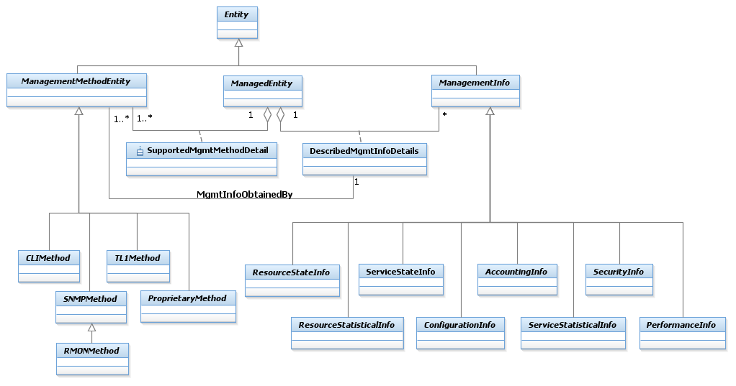
Figure R.01 - ManagementInformation and Methods for Obtaining Management Data
This figure is taken from the Logical and Compound Resource addendum Figure LR.54 - Concepts of ManagementInfo and ManagementMethodEntity. A fundamental characteristic of a ManagedEntity is that it can perform management functions and/or collect management information. ManagementMethodEntity represents the means in which management information is obtained, and ManagementInfo represents the specific type of management data obtained.

Entity Specification
This section describes the main EntitySpecification classes in the SID.
An EntitySpecification is an abstract class that extends the RootEntity class in order to define shared characteristics for any type of specification entity. EntitySpecifications exist many SID Entities. This is illustrated in Figure R.05 - View of the EntitySpecification Class Hierarchy below.
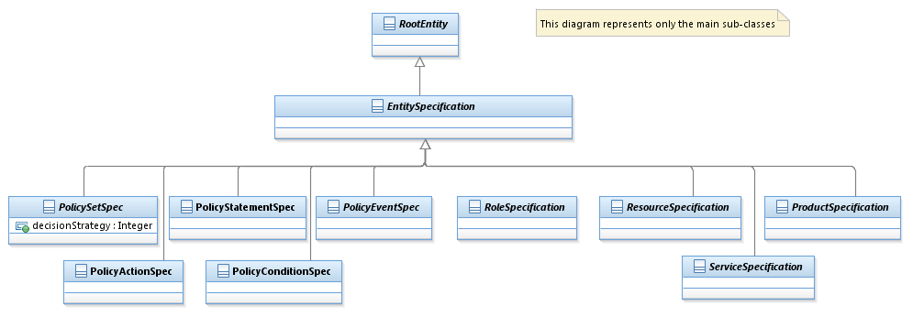
Figure R.05 - View of the EntitySpecification Class Hierarchy
The EntitySpecification – Entity pattern, shown in Figure R.06 - The EntitySpecification – Entity Pattern below, enables all Entities to be abstracted such that their shared attributes are captured in the EntitySpecification via inheritance from RootEntity and their shared associations inherited from those that Entity has with other entities, such as EntityIdentification. This enables each Entity to define its own distinguishing attributes in addition to the common attributes and associations defined by EntitySpecification.
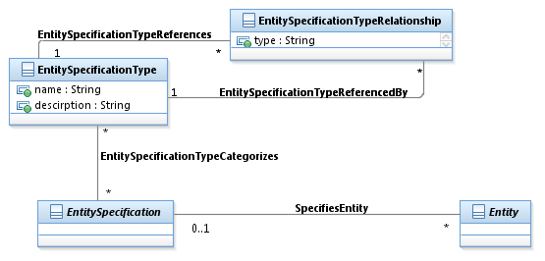
Figure R.06 - The EntitySpecification – Entity Pattern
Note that in the figure the association between EntitySpecification and Entity is implied and not a UML association. This was done so that the association between EntitySpecification and Entity is not inherited by all their subclasses. This would cause a problem, because any instance of an EntitySpecification could be associated to any instance of an Entity. For example an instance of ProductSpecification could be associated to an instance of Service. The 0,1 association multiplicity on the association means that not every entity has to have an associated EntitySpecification. For example, an instance of a discovered Resource may not have a known instance of ResourceSpecification associated to it.
Also shown in the figure are an EntitySpecificationType and an EntitySpecificationTypeRelationship. This provides a consistence way to define relationships among entities that inherit from EntitySpecification. This is further demonstrated in the next figure, Figure R.07 - EntitySpecificationType Inheritance.
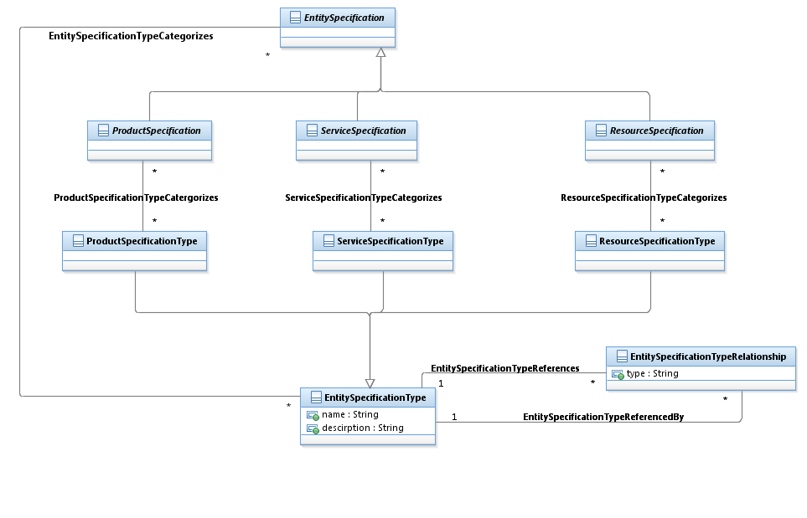
Figure R.07 - EntitySpecificationType Inheritance
The relationships between the subclasses of EntitySpecification and Entity are shown in Figure R.08 - Interaction Between EntitySpecification and Entity Classes below.
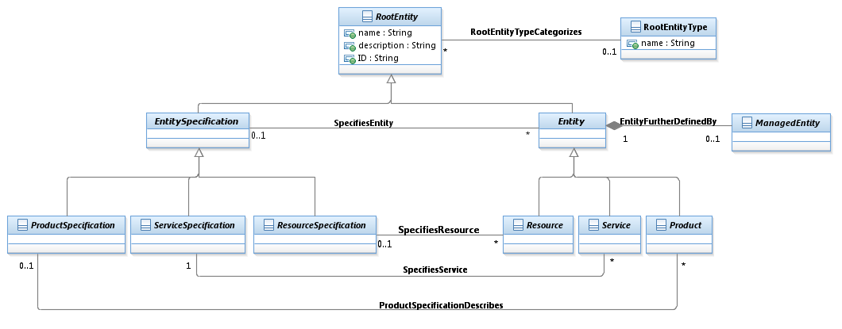
Figure R.08 - Interaction Between EntitySpecification and Entity Classes
The figure shows explicit associations between the specification entities and their respective entities. For example, ProductSpecification has an explicit association with Product.

Role
Roles represent a fundamental way to provide extensibility in the model. The Role Object pattern [ROLEOBJ] is used to extend the use and application of an object. For example, by modeling the different functions that a device can play as a set of objects.

Role Overview
A role characterizes the function that a particular object plays. In the SID, the characterization may be to specify attributes and relationships.
Roles provide an extensible means of abstraction that enables the user to model the functions played by an entity as separate objects (instead of embedding that functionality in the entity itself). For example, suppose that you are modeling the business functions that your employees have. Basic organizational boundaries define some behavior (e.g., marketing vs. sales vs. engineering), but often employees play multiple roles (e.g., an engineer that has sales support functions). This phenomenon doesn’t just occur for people – other managed objects exhibit it as well. For example, in a VPN, some DeviceInterfaces talk to a customer, while others never touch a customer.
In general, managed objects don’t all have the same behavior, but different managed objects may have some common behavior. Worse, an object might exhibit more than one set of common behaviors, or may take on and remove different behaviors during its lifetime. Thus, we need a means to capture these and related cases. A set of role patterns provide an extensible and straightforward means of accomplishing this goal.
Before these different role patterns are discussed, it is important to differentiate between an instance or a type. Asking an object if it is an instance of a type is something different than asking it if it is an instance of a class, since the types (interfaces) and the classes (implementations) can be different. (Note that there are patterns to accomplish this function.)
The SID is concerned with types, not implementation.
There are five types of role patterns that are extensions of [ROLEOBJ], described as follows:
- Single Role Type. This pattern combines all of the features of different roles into a single type, and is most useful for modeling objects having a few variations on the same basic behavior.
- Separate Role Type. This pattern models each role as its own separate type, and is most useful for modeling objects that have little if any common behavior.
- Role Subtype. This pattern models each role that exhibits different behavior as a subtype. Note that this does NOT mean that sub-classing is used, as this is an analysis pattern and is thus concerned with interfaces, not implementation. This pattern is all about maintaining the illusion that clients are dealing with a single object that has multiple, changeable types.
- Role Object. This pattern models each role that exhibits different behavior as a separate object. The separate role objects are then related to a single base object that ties the different behaviors together. This pattern is used when maintaining the illusions of a single object is too difficult, or doesn’t supply the correct semantics.
- Role Relationship. This pattern models each role as a relationship with an appropriate object.
Of these five patterns, the SID uses the fourth – Role Object – almost exclusively. Single Role Type and Role Type aren’t used because they best deal with behavior which is not included in the SID.
This leaves Role Subtype and Role Relationship. The problem with the Role Subtype pattern (in the context of the SID) is that this pattern cannot be used if there are multiple and/or changing roles.
The Role Relationship pattern is not used in the SID due to its complexity. This pattern is very well suited when the role itself embodies a relationship between a base object and some other object (usually a group). For example, consider an organization which requires new employees to spend an equal amount of time working for multiple departments. In this case, the role binds the person to the particular organization that he or she is currently working for. Thus, it is best modeled as a relationship between the person and the organization that the person is working for.
Figure R.09 - The Basics of Roles – An Example below shows a simplified view of the concepts of using the Role Object pattern.
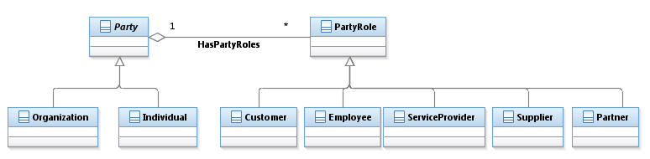
Figure R.09 - The Basics of Roles – An Example
The figure shows that an Individual (or an Organization) can be assigned zero or more roles. Thus, an Employee can take on the roles of ServiceProvider and Partner.

The idea is to define the functionality that a business entity can play as a set of subclasses of EntityRole, and then associate the specific functionality that is desired using the EntityHasRoles aggregation. This enables the functionality and behavior of the business entity to be easily customized. For example, consider two different people working in the same department – both interact with a customer, but Bob is a manager and Joe isn’t. Rather than add employee-specific attributes to the definition of a Person, a Person can be kept general, and employee-specific attributes can be added to an appropriate role.
More formally, roles recognize the fact that different entities may have different roles that it can play when it collaborates with other entities in the system. Separating this into different roles enables behavior to be defined that involves just the role, as opposed to all of the attributes of the entity. This enables the communication to become more specific and thus easier to generalize.

Different Types of Roles in the SID
The SID is unique, in that roles are used in the vast majority of its domains, to ensure that the above philosophy is applied wherever it makes sense. Three different examples that show the diversity of roles in the SID are as follows:
- Party and PartyRole (Party addendum). Party is a superclass for modeling people and organizations, and PartyRole is a superclass for modeling the different jobs that people can have.
- Resource and ResourceRole (Physical Resource addendum and Logical and Compound Resource addendum). Resources are physical, logical, and compound resource entities that represent the definition, development, and operational aspects of the information computing and processing infrastructure of a system. There are PhysicalResourceRoles as well as LogicalResourceRoles, which enable functions associated with the physical and logical aspects, respectively, of a resource to be modeled independent of that resource. There are also CompoundResourceRoles, which enable roles to be assigned to CompoundResources (Resources that contain one or more PhysicalResources and LogicalResources).
- Service and ServiceRole (Service Overview addendum and Quality of Service addendum). Services represent intangible functionality that is provided by the information computing and processing infrastructure of a system. CustomerFacingServiceRoles represent abstracted functionality that represent how a Product is realized, while ResourceFacingServiceRoles represent abstracted functionality that are required in order for the CustomerFacingService to function correctly.
All of these are currently defined in various GB922 Addenda except as noted above.

RoleSpecification
RoleSpecifications exist to help standardize the functionality and use of roles.

RoleSpecification Overview
A RoleSpecification is an abstract class that extends the Specification class in order to define the attributes shared by instances of the associated Roles. In general, if a Role is used, it is also advisable to use a RoleSpecification, since RoleSpecifications enable a set of Roles:
- to be specified as a set of common abstractions which are used throughout an application
- to have their shared characteristics defined in a standard way
- to indirectly specify the set of Roles that must be used to abstract the functionality that is to be modeled.
The principal RoleSpecifications currently defined are:
- PartyRoleSpecification provides a way to define attributes shared by instances of related PartyRoles and to dynamically define new types of roles without having to explicitly add a subclass of PartyRole.
- ResourceRoleSpecification is the superclass for PhysicalResourceRoleSpecs, LogicalResourceRoleSpecs, and CompoundResourceRoleSpecs.
- ServiceSpecificationRole is the superclass for CustomerFacingServiceRoleSpec and ResourceFacingServiceRoleSpec.

EntityRole
An EntityRole is an abstract class that extends the Role class to define the concept of various types of roles for Entities. Figure R.10 - Associating EntityRoles with an Entity below shows the relationships between an Entity, an EntitySpecification, a RoleSpecification, and an EntityRole.
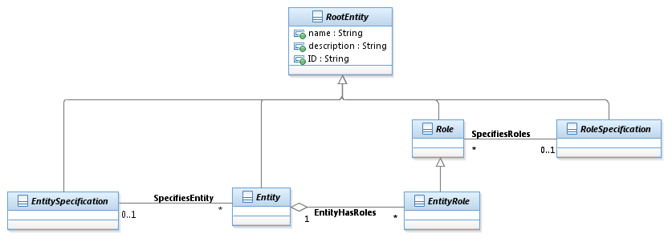
Figure R.10 - Associating EntityRoles with an Entity
RoleSpecifications can be used to assign different types of Roles to an Entity. This is done using the SpecifiesRoles association.

ManagementDomain
ManagementDomain represents a special grouping of ManagedEntities that has two important properties. First, it is used to partition managed objects into a meaningful logical grouping. One important use of such a grouping is to provide a means to define which EMS (as well as which NMS) manages, monitors, etc. which set of devices. Another important use of such a grouping is to provide a means to show how management functions are distributed and scaled.
Second, this grouping defines a common administrative domain that is used to administer the managed objects that it contains. This implies that all of the managed objects contained in this ManagementDomain are administered similarly – either by the same user, group of users or policy.
A ManagementDomain is the superclass of several important entities in the SID. One of the most important of these is the PolicyDomain class. A PolicyDomain is a collection of entities and services that are administered in a coordinated fashion using a set of policies. The policies are used to control the set of services and entities according to a common methodology, such as a finite state machine. This is defined in Policy addendum.
The ManagementDomain class also enables relationships to be defined that convey various semantics, such as containment, scoping, administration, and more generic management functions.

ManagementInfo
ManagementInfo is an abstract class that is used to represent entities that represent management information obtained in a managed environment. Specifically, in the process of managing an entity, information of various forms is created. This class is the superclass for defining different types of management information. Its main subclasses are shown in Figure R.11 - ManagementInfo Class Hierarchy below.
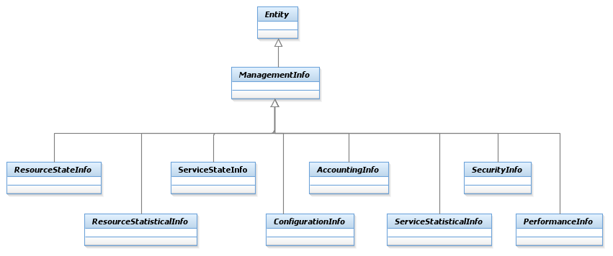
Figure R.11 - ManagementInfo Class Hierarchy
The design of how management information is obtained uses this class to gather specific types of information, and the ManagementMethodEntity class to obtain the desired data using an appropriate method. This combination of class hierarchies enables different management methods (e.g., CLI vs. SNMP) to be used to gather different types of management data, and is unique to the SID information model.

ManagementMethodEntity
ManagementMethodEntity is an abstract class for representing the different types of management methods that can be used to gather a particular type of management information. For example, this enables configuration setting classes to be defined as using CLI, while configuration monitoring classes could be defined as using a different method, such as SNMP. Its main subclasses are shown in Figure R.12 - ManagementMethodEntity Class Hierarchy below.
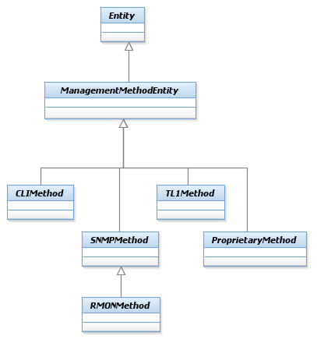
Figure R.12 - ManagementMethodEntity Class Hierarchy
The design of how management information is obtained uses this class to gather specific types of information, and the ManagementMethodEntity class to obtain the desired data using an appropriate method. This combination of class hierarchies enables different management methods (e.g., CLI vs. SNMP) to be used to gather different types of management data, and is unique to the SID information model.
Figure R.04 - ManagementInformation and Methods for Obtaining Management Data showed how ManagementInfo and ManagementMethodEntity work together to provide a single, scalable solution for gathering different types of management information that describe a management entity. This is especially important for some types of network devices, where different protocols and approaches are used to configure vs. monitor the device.

Identification
Business entities consist of two types – those that are simple values, such as a quantity of money or a period of time, and those that have identity. For these latter entities, the concept of an identity is used to distinguish different instances of the same object.
Identity is flexibly and extensibly defined using the group of objects defined in this chapter.

Identification Overview
Individual people, places, and things, such as customer orders, equipment, network elements and so forth, can be recognized (identified) by different attributes. The business will define (usually through a policy) what particular set of attributes or concepts is appropriate for a given entity. For example, an individual person may be identified using a passport number, a driver’s license number, or a national identification number. Similarly, a network location may be identified by a network node ID or a Location Entity Identification Code (as defined in American National Standard T1.253).
It should be noted that policy does not have to be used. However, the use of policy provides an elegant and extensible means to define the semantics of using an identity. This is done by modeling associations between PolicyRules and the identification entities that it relates to.

PartyIdentification Overview
Figure EI.01 - PartyIdentification Excerpt (taken from Party addendum) below shows an excerpt for identifying different types of Parties (e.g., Individuals and Organizations).
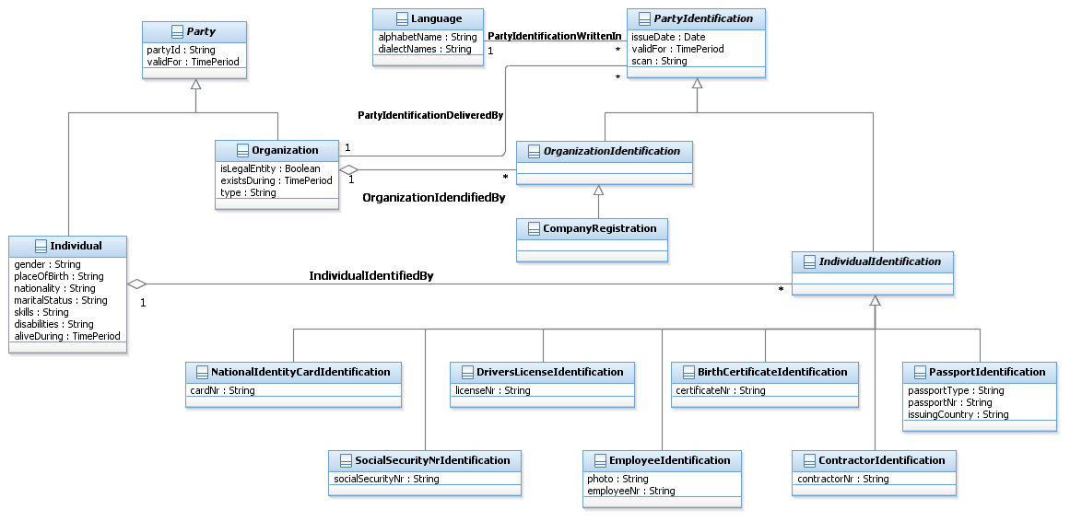
Figure EI.01. - PartyIdentification Excerpt (taken from Party addendum)
The manner in which each key business entity in the SID model is identified could be modeled in a way similar to Party. However, each business entity can be identified in a number of ways, as shown in the example above for individuals. Modeling the identity in this way means that each key entity would have a set of classes similar to those used to model the identities of Party. This introduces redundancy into the SID model for every entity that requires identification. In addition, using explicit subclasses to model the different types of identification attributes for an entity results in a model that cannot be easily extended. This is because as new ways to identify an entity are defined or discovered, a new subclass must be introduced into the SID model. Having to introduce new subclasses implies that the parts of the SID model that represent entity identifications are not very stable. It also makes it difficult for other teams and I to adopt the SID, since its baseline is always changing.

EntityIdentificationSpecification
To eliminate the redundancy and instability within the model caused by the repeated modeling of similar identification structures and by introducing subclasses for each way that an entity can be identified, the EntitySpecification – Entity pattern is used. Here, the “EntitySpecification” part of the pattern will take the form of a specification for identifying Entities, and the “Entity” part of the pattern will take the form of an object that can be used to identify entities.
Therefore, applying this pattern yields the beginning of a model for Entity identification, as shown in Figure EI.02 - Beginning of the Entity Identification ABE Model below.
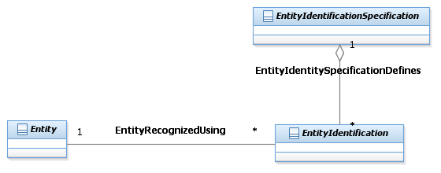
Figure EI.02 - Beginning of the Entity Identification ABE Model
An EntityIdentificationSpec defines the attributes that are shared by every instance of a related EntityIdentification. (and methods, constraints, relationships and behavior in the system view) of an EntityIdentification object. Note that methods and constraints (as specified in OCL) are useful for specifying “static” behavior (e.g., functionality that can be defined at design time). Thus, “behavior” refers to dynamic functionality and runtime considerations that are not easy to represent in a class model. For example, the directive to instantiate an object only in response to a run-time exception is easy to conceptualize as a constraint, but is difficult to model in UML. Other examples include the specification of pre- and post-conditions and other contract related data.
As the identification model is further developed in this addendum, the EntityIdentificationSpecification will be expanded to include business entities that define the structure and format of Entity identifiers. The EntityIdentification entity will similarly be expanded to show the structure for values of Entity identifiers and the Entities they identify.
An Entity identifier could be a single attribute or a composite of two or more attributes. For example, a network node ID is a single attribute that identifies a network location; the 8-byte Network Site Format of ANS T1.253 used to identify a building is a composite of a Geographical Code, a Geopolitical Code, and a Network Site Code. Applying the composite pattern to Entity identification captures this concept, and provides the ability to extensibly define EntityIdentificationSpecifications. The composite pattern is shown in Figure EI.03 - The Composite Pattern Applied to EntityIdentificationSpecification below.
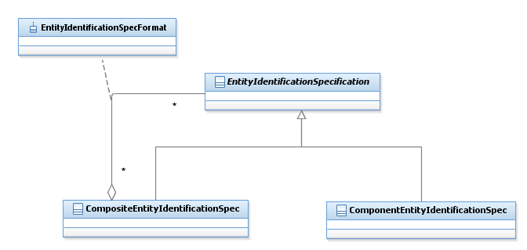
Figure EI.03 - The Composite Pattern Applied to EntityIdentificationSpecification
An EntityIdentificationSpecification represents one or more attributes (not attribute values) used to recognize (identify) an instance of an Entity. Figure EI.04 - EntityIdentificationSpecification Examples below shows an 8-byte Network Site Format using ANS T1.253. Note that the various component specifications (Geographical Code, Geopolitical Code, and Network Site Code) that make up a complete Network Node ID, which is represented as an CompositeEntityIdentificationSpec object, are represented as instances of the ComponentEntityIdentificationSpec, and are aggregated by the CompositeEntityIdentificationSpec.
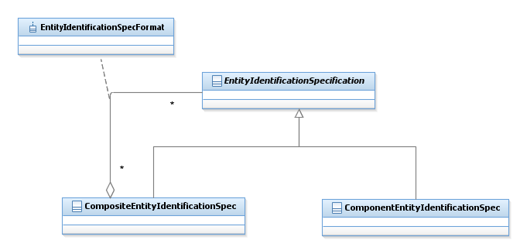
8-byte Network Node ID Format
Geographical Code
Geopolitical Code Network Site Code
4 byte Geographical Code
2 byte Geopolitical Code
2 byte Network Site Code
Figure EI.04 - EntityIdentificationSpecification Examples
The component specification must be able to occur in a certain sequence to define the composite. And, they may be preceded and/or followed by certain characters. For example, the format of a phone number could contain dashes, such as 972-477-8401. Figure EI.05 - The EntityIdentificationSpecificationFormat Association Class below shows an association class added to hold the sequence in which the components appear in a composite object, along with its formatting attributes.
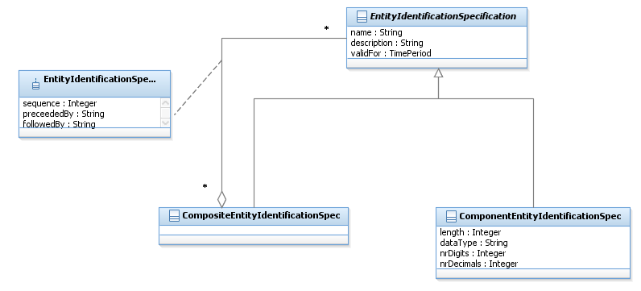
Figure EI.05 - The EntityIdentificationSpecificationFormat Association Class

The next thing that must be known about an EntityIdentitySpecification is what type of business Entity the EntityIdentitySpecification applies to. There are two different means of doing this. The difference is whether the Entity being identified has an associated EntitySpecification or not. For example, a Market Entity has no associated Specification, whereas a Resource Entity or a Service Entity often do have an associated EntitySpecification.
The first option is shown in Figure EI.06 - Identifying Entities Using an Associated EntitySpecification. In this option, an EntitySpecification defines a Entity as well as a set of EntityIdentificationSpecs. Any of these EntityIdentitySpecs may be used to identify the EntityIdentification object that is used to identify the associated Entity. Looking at Figure EI.06 - Identifying Entities Using an Associated EntitySpecification below, we see that the EntitySpecification that characterizes the Entity contains, in addition to its invariant attributes, zero or more EntityIdentificationSpecs. The EntityIdentitySpecification in turn specifies the set of EntityIdentification objects that can be used to identify the Entity that the EntitySpecification applies to. This enables the EntitySpecification to in effect direct the usage of a subordinate specification (the EntityIdentitySpecification) to indirectly define EntityIdentification objects that can be used to identify the Entity to which the EntitySpecification applies to, providing a great deal of inherent flexibility in determining how the Entity will be identified.
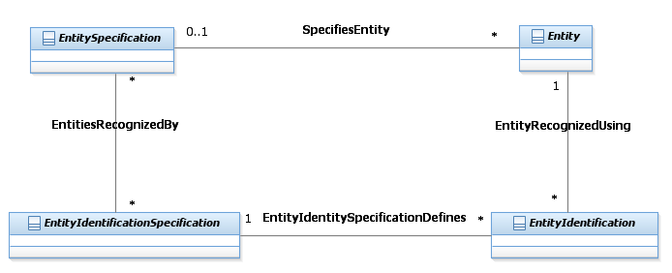
Figure EI.06 - Identifying Entities Using an Associated EntitySpecification
The second option is shown in Figure EI.07 - Identifying Entities Using the RootEntityType Entity below. This option is used for Entities that don’t have an associated EntitySpecification, and can also be used in the first case if desired. This option introduces an entity (called RootEntityType) into the model whose instance is the business entity that is to be identified. Examples of business entities that use this approach include Location (identified by the 8-byte Network Site Format), Individual, Organization, Customer, Supplier, Market Segment and so forth.
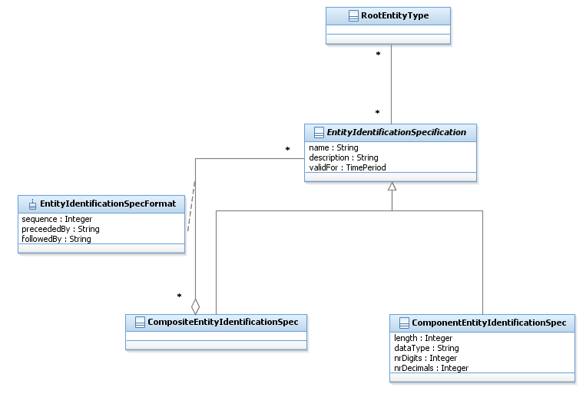
Figure EI.07 - Identifying Entities Using the RootEntityType Entity
Two association classes are introduced in the Entity identification model as shown in Figure EI.08 - Use of an Entity Identification Specification below. The EntityIdentificationSpecFormat association class, which was first shown in Figure EI.07 - Identifying Entities Using the RootEntityType Entity above, is used to define the formatting and sequencing of EntityIdentificationSpec objects that are aggregated by a particular EntityIdentificationSpecComposite object. The RootEntityTypeIdentificationSpec association class, shown in Figure EI.08 - Use of an Entity Identification Specification below, is used to indicate, via its use attribute, whether the entity identification specification is used as the primary or as a secondary identifier.
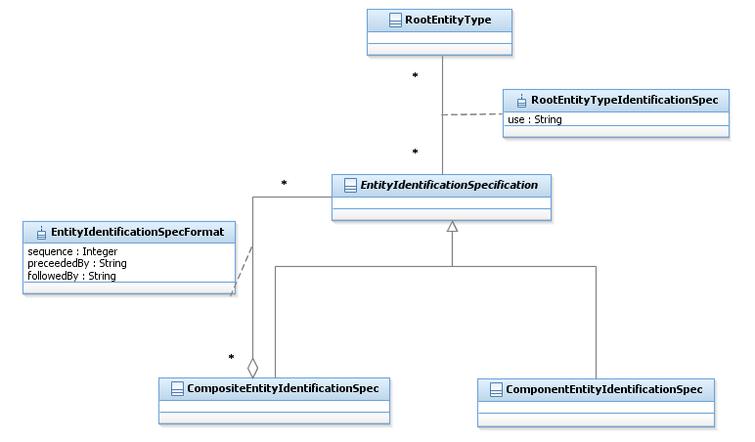
Figure EI.08 - Use of an Entity Identification Specification
The following example shows where both approaches may be used. In some cases, for example if a manufacturer has a special identification scheme for a certain type of equipment, it may be necessary to associate an EntityIdentificationSpecification to a specific EntitySpecification. This type of association would specify that the EntityIdentificationSpecification is only applicable for equipment Entity instances related to the instance of the equipment EntitySpecification and not for equipment Entity instances related to other EquipmentSpecifications below shows the association between an EntityIdentificationSpecification and an EntitySpecification.
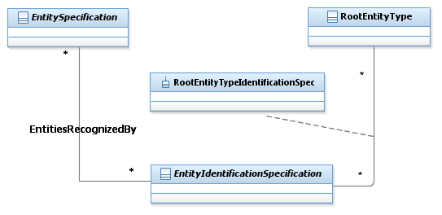
OR
OR
Figure EI.09 - EntitySpecification Association With EntityIdentificationSpecification

EntityIdentification
Every instance of an entity has a unique identifier. Simple identifiers can be defined as attributes of an entity. In cases where one or more complex identifiers are required, an object is required. This is implemented using an entity identification specification and its associated entity identification objects. For example, ANS T1.253 specifies a complex identifier for a network location Figure EI.10 - Entity and Entity Identification below shows an example of the EntityIdentificationSpecification, the EntityIdentification, and the RootEntity instance identified using this specification. (Note that the multiplicity of the RootEntityRecognizedUsing association is 0..1 on the RootEntity side, and not 1, because our first option doesn’t use this approach; therefore, RootEntity and RootEntityType must be kept optional.)
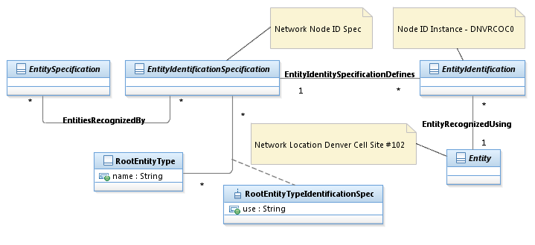
Figure EI.10 - Entity and Entity Identification

Additional Entity Identification Examples
This section contains additional examples that depict the use of the Entity Identification Specification and Entity Identification. The examples are taken from the American National Standard T1.253-1999.

Customer Site Format
This is a standardized code that uniquely identifies a customer’s presence at a location at which network elements or network systems equipment exists.

Components

Geographical Code
The designation for a single geographical locality within a state, province, territory, country, or distinct region of the world (e.g., municipality). This data element shall consist of four alphabetic characters. New codes assigned shall contain exactly four characters and shall not contain spaces. For previously assigned codes of less than four characters, the unused character positions after the code shall be filled with spaces to make up four character positions.
Geopolitical Code
The designation of a state or territory of the United States, a province or territory of Canada, another country having a national federal government, or a unique designation (e.g., the oceans). This data element shall consist of two alphabetic characters.
Customer Site Code
The designation of a customer that utilizes telecommunications equipment at a specific location where there is a requirement to uniquely identify that customer’s presence for the purpose of inventory and facility management.
This data element shall consist of five characters having one numeric character in the first position followed by one alphabetic and three alphabetic or numeric characters in that sequence.
Customer Site Format Table
This format shall consist of a sequence of Geographical Code and Geopolitical Code data elements plus a Customer Site Code data element, resulting in a code that totals eleven characters in the format shown in the table below.

ELEMENTS/POSITIONS | 1 2 3 4 | 5 6 | 7 8 9 10 11
Geographical Code | A A A A
Geopolitical Code |  | A A
Customer Site Code |  |  | N A A/N A/N A/N
Table R.x – Customer Site Format
Figure E.11 - EntityIdentificationSpec Example below shows this format overlaid on the EntityIdentitySpecification ABE previously discussed. First, we need to define some more components from ANS T1.253-1999.

Equipment Entity Identification Format
A standardized code that uniquely identifies a type of manufactured telecommunications network equipment or an assignable entity within a type of equipment. The Equipment Entity Identification Format shall consist of a sequence of Family Code, Sub-Family Code, Features Code, Reference Code and Complemental Code data elements, resulting in a code that totals ten characters in the following format:
Components

Family Code
A label to denote a functional category of manufactured telecommunications equipment. This data element shall consist of two characters, either of which may be alphabetic or numeric. An example is D4, representing a D4 channel bank.
Sub-Family Code
A label to denote a functional category of manufactured telecommunications equipment within a family. This data element shall consist of two characters, either of which may be alphabetic or numeric. An example is CE, representing an E&M signaling channel unit.
Features Code
A standardized code to denote a distinctive service-providing design capability available within a sub-family of manufactured telecommunication equipment when compared to other similar equipment of the same or other manufacturers. This data element shall consist of three characters, each of which may be alphabetic or numeric. Manufacturers’ examples are:
- 18B, where
- 1 signifies E&M signaling, 4 wire
- 8 signifies E with M lead applique, M lead resistor 510 ohm
- B signifies with busy switch and level adjust attenuator
- 424, where
- 4 signifies DX signaling, 4 wire with post equalization
- 2 signifies adjustable balance capacitance and resistance
- 4 signifies impedance 150/600/1200 ohm
- 363, where
- 3 signifies DX signaling, 2 wire with gain transfer
- 6 signifies eliminate signaling condition, fixed balance capacitance
- 3 signifies receive enable circuit

Reference Code
This is a label to denote the manufacturer’s information used to describe the design capability encoded in the equipment entity identification code. This data element shall consist of one character, which may be alphabetic or numeric. Examples are:
- 7, signifying NNTM
- 8, signifying LEAR
- P, signifying SD-7C026-02

Complemental Code

This is a standardized code to provide uniqueness to an equipment entity identification code. This data element shall consist of two characters, either of which may be alphabetic or numeric. (Examples of typical information are manufacturing vintage, version data, circuit wiring, or equipment data.) Examples are:
- AA, for Northern Telecom, signifying NNTM QPP357B
- AA, for LEAR, signifying LEAR D4DX-4010-11
- AB, for Lucent Technologies, signifying J98726SD-2

Composites

Basic Code

A Basic Code is comprised of the Family Code and Sub-Family Code data elements taken together, represented in the following format:
ELEMENTS/POSITIONS | 1 2 | 3 4
Family Code | A/N A/N
Sub/Family Code |  | A/N A/N

ELEMENTS/POSITIONS | 1 2 | 3 4 | 5 6 7 | 8 | 9 10
Family Code | A/N A/N
Sub/Family Code |  | A/N A/N
Features Code |  |  | A/N A/N A/N
Reference Code |  |  |  | A/N
Complemental Code |  |  |  |  | A/N A/N

The next two figures show examples of CustomerSiteFormat and EquipmentEntityIdentityFormat within the context of the EntityIdentificationSpecification and EntityIdentification entities.

Geographical Code (GGC)
Geopolitical Code (GPC)
Customer Site Code (CUC)
Family Code (FAC)
Sub/Family Code (SFC)
Features Code (FEC)
Reference Code (REC)
Complemental Code (COC)
Customer Site (CUS)
Equipment Entity Identification (EEI)
CUS GGC 1
CUS GPC 2
CUS CUC 3
EEI FAC 1
EEI SFC 2
EEI FEC 3
EEI REC 4
EEI COC 5
Figure EI.11 - EntityIdentificationSpec Example

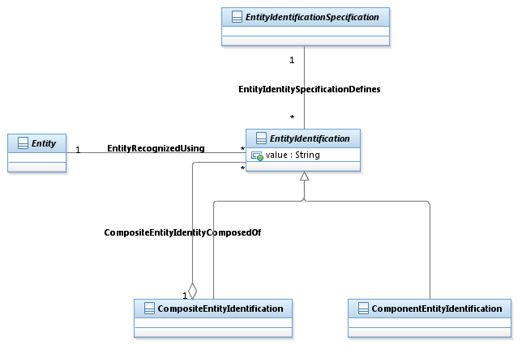
CUS #1 (PLANTX1APBX)
CUS #2 (DNVRCO1APBX)
EEI #1 (AABBCAC151)
EEI #2 (DDEEDID261)
Customer Site (CUS)
Equipment Entity Identification (EEI)
Geographical Code (GGC)
Geopolitical Code (GPC)
Customer Site Code (CUC)
Family Code (FAC)
Sub/Family Code (SFC)
Features Code (FEC)
Reference Code (REC)
Complemental Code (COC)
CUS #1 GGC - PLAN
CUS #1 GPC – TX
CUS #1 CUC – 1APBX
CUS #2 GGC – DNVR
CUS #2 GPC – CO
CUS #2 CUC – 1APBX
EEI #1 FAC - AA
EEI #1 SFC - BB
EEI #1 FEC - CAC
EEI #1 REC - 1
EEI #1 COC - 51
EEI #2 FAC - DD
EEI #2 SFC - EE
EEI #2 FEC - DID
EEI #2 REC - 2
EEI #2 COC - 61
Figure EI.12 - Additional EntityIdentification Examples

Root Business Entities/Characteristic ABE
Figure Ch.01 - Characteristic Specification depicts the basic CharacteristicSpecification pattern. The pattern enables attributes unique to a type of entity to be created via its association to EntitySpecification and enables attributes unique to a certain entity to be created via its association to RootEntityType. A RootEntityType is an entity in the SID. For example, characteristics could be defined for entities (instances of RootEntityType) such as Product, Customer, and ProductSpecification that apply to all instances of those entities. Instance diagrams are shown in Figure Ch.03 - Characteristic Spec Instance – Example 1 and Figure Ch.04 - Characteristic Spec Instance – Example 2. Definitions of entities and attributes are provided in the data dictionary at the end of this document.
An example of the use of the pattern will also be illustrated using the following figure.
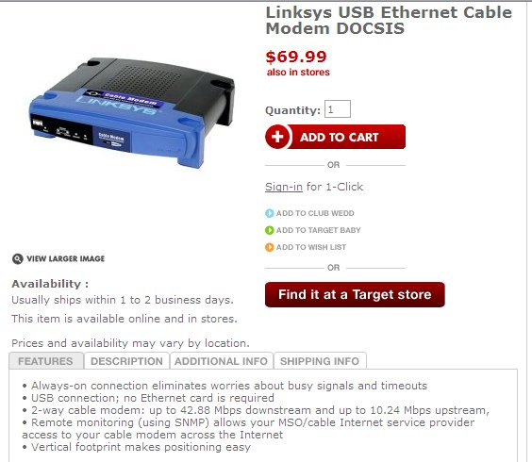
The EntitySpecification, which could be a ProductSpecification, instance is for a Linksys USB Ethernet Cable Modem DOCSIS. Each tab, Features, Description, Additional Info, and Shipping Info is an instance of CharacteristicSpecification. The Features CharacteristicSpec is a composite that is comprised of an instance of CharacteristicSpec for each feature line. Instances of the CharacteristicSpecRelationship are used to compose the Features of the instances of feature line. Instances of EntitySpecCharUse has the canBeOverriden attribute set to true, which means the characteristics cannot have a value specified for them.
In this example, the CharacteristicSpecValue and CharSpecValueRelationship entities are not used. An example of their use could be for a set of coordinated colors for the modem. For example, if a choice for a faceplate color (CharacteristicSpec) is blue (CharacteristicSpecValue), then the only color for the case color is black. This rule would be implemented by an instance of CharSpecValueRelationship that relates the color blue with the color black with a value for charValueRelationshipType of “inclusive”. The charRelSeq is used to sequence attributes that make up a composite CharacteristicSpecification. For example, a composite that represents an US telephone number is made up of an area code, a number plan area, and a number in this sequence. The charRelSeq is used to specify this sequence.

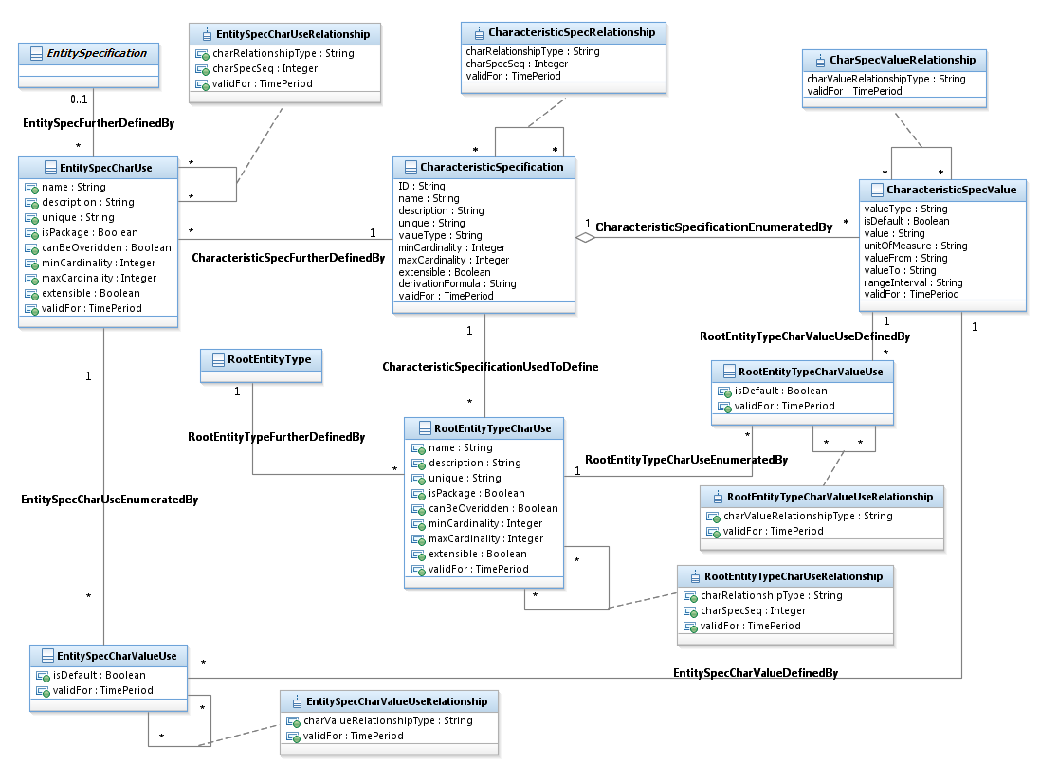
Figure Ch.01 - Characteristic Specification
The minCardinality and maxCardinality attributes are used to specify the number of values that can be associated with an instance of a RootEntity. In the example the faceplate color would have a minCardinality of 1 and a maxCardinality of 1. A minCardinality of 0 implies that a value does not have to be assigned to a characteristic.
A valueType attribute exists for both CharacteristicSpecifications and CharacteristicSpecValue in order to have a mixture of value types for values. For example, a CharacteristicSpecification may be enumerated by a combination of strings and integers. The valueType of the CharacteristicSpecification is used if the valueType is the same for all CharacteristicSpecValue instances.
An instance CharacteristicSpecValues can represent discrete value or a range of values. An example of a discrete value is the values that the CharacteristicSpecification “color” can take on. An example of a range of values is the range of operating temperatures under which the cable modem can operate. A rangeInterval attribute for CharacteristicSpecValue defines whether the valueFrom and valueTo attributes are inclusive or not. This is equivalent to adding an “operator” attribute for valueFrom and an “operator” attribute for valueTo, such as “<=” or “<”.
In some models the value attribute and the range attributes are contained within separate subclasses of the CharacteristicSpecValue entity. This was not done in the Characteristic model in order to simplify it. Also, some models may contain unit of measure as a separate entity with a recursive association and an association class that is used to define conversion factors between various units of measure. This was not done in the Characteristic model. However, both the subclasses and unit of measure entity and association class could be modeled as extensions to the SID if desired.
Some CharacteristicSpecifications are enumerated by a fixed value or set of values that remain constant for every instance of an Entity. For example, the operating temperature range for the cable modem remains constant. The attribute canBeOverriden is used to indicate this. Additionally, the set of CharacteristicSpecValues may be open to extension as values are assigned to instances of EntityCharacteristics. For example, there may be a desire to keep a list of userIDs as instances of CharacteristicSpecValues in addition to their existence as instances of CharacteristicValues. The extensible attribute is used to indicate that new instances of CharacteristicSpeValues can be added as instances of CharacteristicValues are created.
CharacteristicSpecifications can be shared by a number of EntitySpecification and RootEntityType instances. The “use” entity contains attributes that may be specific to a use of the CharacteristicSpecification by an instance of an EntitySpecification or a RootEntityType. For example, a CharacteristicSpec with “bandwidth” value for the name attribute, could be named “download speed” in one use and “upload speed” in another use. The values assigned to these attributes override the values assigned to an instance of a CharacteristicSpecification. For example, the minCardinality attribute assigned to an instance of CharacteristicSpecification may be zero, indicating that a value does not have to be assigned for an instance of a CharacteristicValue; however, for a particular use of the CharacteristicSpecification, the attribute must be assigned a value. In this case the minCardinality attribute in the “use” entity would be assigned a value of one.
The package attribute, also a “use” entity attribute, indicates that the attribute represents a composite attribute, similar to the composite/atomic pattern without the explicit sub-classing. When this attributes value is set to “true” a number of attributes do not apply, such as min and maxCardinality, unique, canBeOverriden, and extensible,.
The use of an attribute by an EntitySpecification or a RootEntityType may also require a further restriction on the values that a Characteristic can be assigned. The associations between CharacteristicSpecValue and the “use” entities can be used to define the further restriction. For example, the instances of CharacteristicSpecValue for the instance of the “color” CharacteristicSpecification may contain the entire rainbow of colors, but only a subset of colors is available for the cable modem.
Similarly, the two “SpecValueUse” entities enable different default values to be specified for the use of values associated with the use of a CharacteristicSpecification by an EntitySpecification or a RootEntityType.
Note: CharacteristicSpecification can be related to specification entities in a number of ways. The relationship can be inherited if a specification entity is a subclass of EntitySpecification or via a direct association between the CharacteristicSpecification and the specification entity.
Figure Ch.02 depicts CharacteristicValues and their association to Entities, in the figure a RootEntity. A CharacteristicValue is one chosen or entered for an Entity for a specific CharacteristicSpecification. In the example above the instances would be “blue” for the face plate and black for the case. The values would be related to the respective CharacteristicSpecValue.
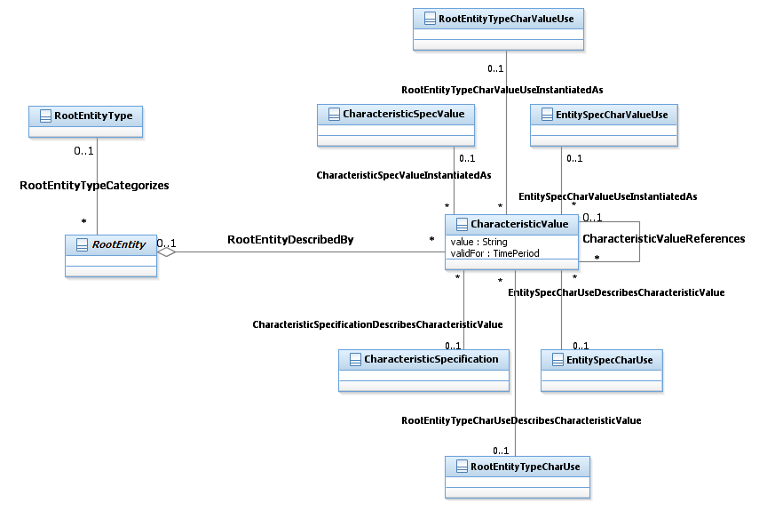
Figure Ch.02 - Characteristic Value
When values are not specified in CharacteristicSpecValue or the other “spec value” entities shown in the figure, but are entered for a CharacteristicSpecification, then CharacteristicValue is related to CharacteristicSpecification or one of the other “spec” entities shown in the figure. For example, a startTime is a CharacteristicSpecification for a Video on Demand, an entered value of 6 Aug 2007 would be related to startTime. This one of the two cases when a CharacteristicValue would be related to a CharacteristicSpecification and when the value attribute of CharacteristicValue would have to be populated. The other case is when a value is chosen from a range of values defined by the CharacteristicSpecValue. When a CharacteristicSpecValue is chosen from a list of discrete values or it is unchangeable (via the canBeOverrided attribute set to “false”), there is no need to populate the value attribute, unless performance considerations required this from an implementation perspective. In these cases the instance of CharacteristicValue is related to the instance of CharacteristicSpecValue and not the instance of CharacteristicSpecification.
Note: CharacteristicValue can also be directly related to an entity, such as ServicePerformance or Customer if they do not inherit from the RootEntity.
Figure Ch.03 - Characteristic Spec Instance – Example 1 shows an example of an IPTV EntitySpecification with three associated CharacteristicSpecifications.
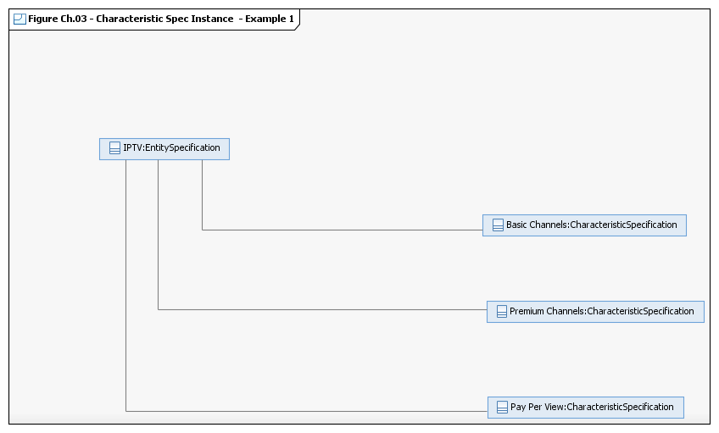
Figure Ch.03 - Characteristic Spec Instance – Example 1
Figure Ch.04 shows how characteristics can be added for an entity whether the entity has an associated specification or not. In the figure two characteristics have been added to the Service Entity in general, independent of those that may be added to instances of ServiceSpecifications. The RootEntityType in the SID is populated with a list of all business entities contained in the SID. The Characteristic model shown in Figure 27 shows how CharactersticSpecifications are be associated with the RootEntityType.
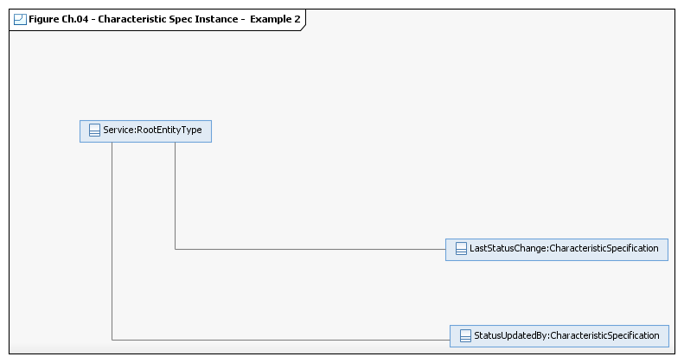
Figure Ch.04 - Characteristic Spec Instance – Example 2
Characteristic-Based Pricing and Charging
In the not-so-distant past factors influencing the price of a product were based on the usage of network resources and other resources, measured by such factors as amount of time, or some other unit, a resource was used or the amount of bandwidth consumed. But once the usage of other types of resources, such as content, is included, many other characteristics influence the price.
This model was originally envisioned to support content pricing and charging, but it can be used for any type of pricing and charging that is based on characteristics and their values. As will be seen it can also be used for usage-based pricing d charging also.
Policy versus Simplicity
When rules for pricing (and charging) were first being developed in the Information Framework (SID) many years ago, Reliance on the policy model was not total. An additional set of entities were under development to support simple rules, such as quantity-based pricing and tiered-based pricing. However, this additional set was not introduced in the released version of the SID. Rather, all rules relied on policy. Many members believe that using only policy is a bit extreme. A balance can be achieved between simplicity and complexity.
This balance was introduced into the SID in release 6.0 with the addition of an association between ProductSpecCharacteristicValue and ProductOfferingPrice. This provided a simple rule that enabled a price to be dependent on value(s) of one or more characteristics.
This balance continued in SID in release 9.0 with the arrival of a new Level 2 ABE (Aggregate Business Entity, a cohesive group of entities) named Pricing Logic Algorithm within the Product Offering Level 1 ABE. This ABE used Product Specification Characteristics to provide support for pricing that involves parameters which are multi-dimensional matrices, in which each dimension is defined by the valid values for a specific characteristic. For example, a PLA which rates events based on customer type, there is one instantiation in which customer type is either residential or commercial (and in which case the size of the dimension of the matrix is 2) and in other instantiation the customer type can be student, normal and senior citizen (in this case the size of the dimension is 3).
And, the use of a simple approach is used here.
The Characteristic Model
The generalized application of the CharacteristicSpecification/CharacteristicValue pattern will be used to demonstrate this.
The Pricing and Charging Scenario
A typical and simple scenario will be used to demonstrate the model. Pay per view Video on Demand (VoD) product depends on the format, standard (STD) or high definition (HD) with a special price given for certain movies viewed in HD during a Saturday and Sunday period.
Shown in Figure Ch.05 - Content Characteristic Specs is an Object Diagram that shows how the current model supports movies. There are other attributes associated with a movie, such as run time, director, and so forth that are not shown in this example.
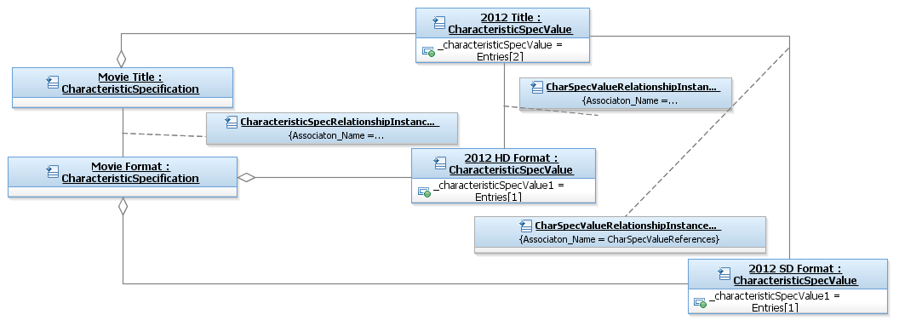
Figure Ch.05 - Content Characteristic Specs
In this example, 2012 is available in both high definition (HD) and standard (STD) formats. This is specified by the relationship between the CharacteristicSPecValue instance 2012 and the two format instances. The Movie Title CharacteristicSpecification instance represents a composite of other specification instances that describe the Movie, such as Title shown in the figure.
The use of the EntitySpecification/Entity pattern was considered to support the requirements. However, this would proliferate the number of EntitySpecifications and Entities from an implementation perspective. In this example, there would have to be a separate instance of EntitySpecification for each movie and a separate instance of an Entity for each chosen movie. Using the generalized CharacteristicSpecification/Characteristic model eliminates this. In this example there could be a single instance of an EntitySpecification that represents Pay Per View and a single instance of and Entity that represents a Pay Per View subscription.
Enhancements to the Characteristic Model
- Add two new entities to the characteristic model
- Add associations to ProductOfferingPrice and ComponentProductPrice.
Also, catalogs of movies can be created by adding a composite CharacteristicSpecification named Video Catalog and associating the Movie Title composite with it. Since this is dependent on the “use” of the values, a recursive association on EntitySpecCharValueUse is required. A similar association and association class is also added to EntitySpecCharUse as shown in Figure Ch.06 - Updated Characteristic Use Entities.
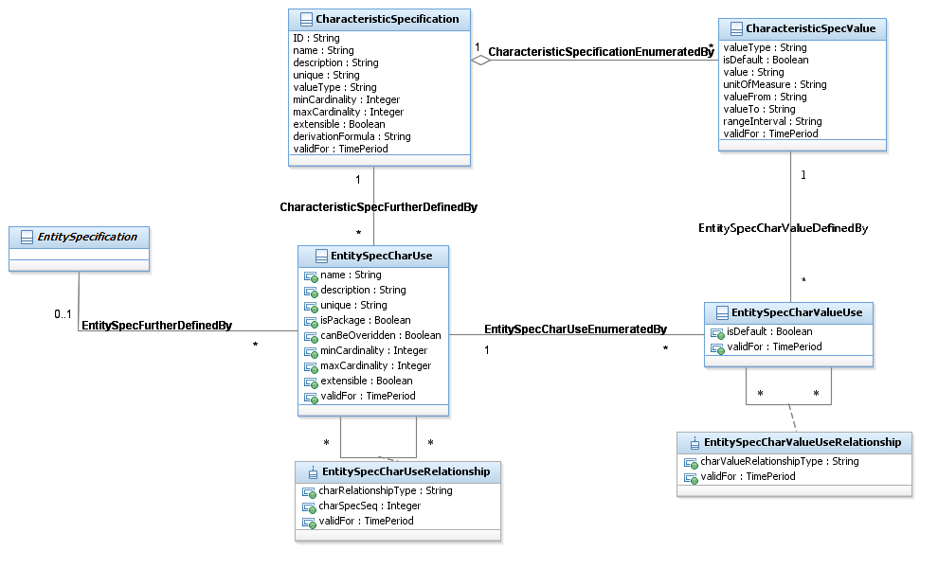
Figure Ch.06 - Updated Characteristic Use Entities

Shown in Figure Ch.07 - Characteristic Specs and Pricing is one of the promoted “use” association classes and two new price dependency entities. These two entities enable a single or multiple attributes (assuming a simple “and” association between the attributes) to govern a price. In the figure the price is represented as ComponentProdOfferPrice, an existing entity in the Product Offering Price ABE.
More comprehensive requirements, such as and’s and or’s, are supported by adding appropriate attributes to the member entity. An Object diagram follows to show an example.
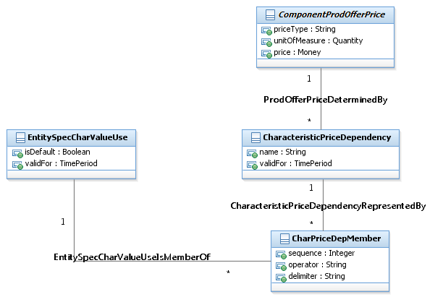
Figure Ch.07 - Characteristic Specs and Pricing
Shown in Figure Ch.08 - Content Charging Offer Price is an example where the high definition (HD) format for the movie 2012 has one price, while the same movie has a different price for standard (STD) format.
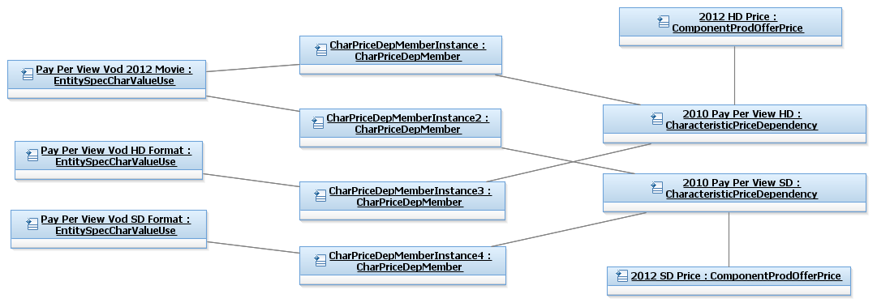
Figure Ch.08 - Content Charging Offer Price
The STD and HD values do not have to be repeated as instances of CharacteristicSpecValues. The Format instance of CharacteristicSpecification can be shared among all movie titles. The names of the objects in the diagram are illustrative only. If the price varied only by HD and STD and not by title then dependencies could be created that were only related to the format values.
If the pay per view price was the same for every movie, then there would be no need for this type of pricing. The current Product Offering to Product Offering Price association would be support this. Also, the ProductOfferingPrice name is illustrative only; the price can be shared by multiple CharacteristicPriceDependencies.
Note that an attribute may be required in Product Offering and/or Product Specification to indicate that choices can be made when accessing an associated Product.
By relating price dependencies to the “use” entities:
- A VoD subscription offering with unlimited free viewing with a fixed subscription price can be created by not associating use attributes with price dependencies and associating a ProductOfferingPrice to the VoD subscription offering
- A VoD subscription offering with unlimited free viewing except for “special” movies can be created by associating only the specials uses with price dependencies and associating a ProductOfferingPrice to the VoD subscription offering
- A VoD pay per view offering can be created by associating appropriate use attributes, such as title and format, with price dependencies.
In the Product domain this could be done for Offering, Specs, or some combination.
Shown in Figure Ch.09 - Complex Content Charging Offer Price is a more involved price dependency. The 2012 movie in high definition (HD) format is available for Saturday or Sunday night viewing at a special price. The dependency can be interpreted as “2012 and HD and (Saturday Viewing or Sunday Viewing)”.
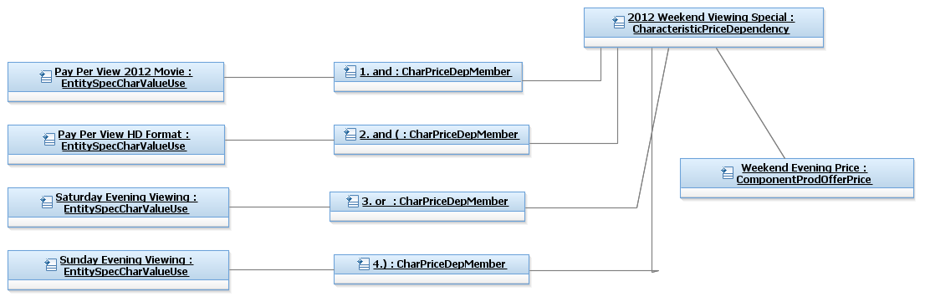
Figure Ch.09 - Complex Content Charging Offer Price

Shown in Figure Ch.10 - Content Charging Product Offer Example is an example of associating the characteristics with a Product Offering. There are no associated EntitySpecCharValueUses, which implies that all movie titles are available in all formats. The choices can be limited by associating values with the Pay Per View Offering.
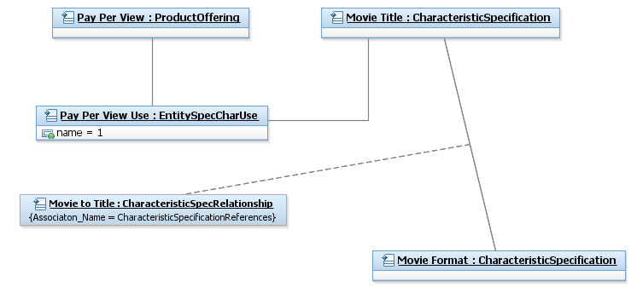
Figure Ch.10 - Content Charging Product Offer Example
By using the generalized characteristic pattern other variations, such as usage-based pricing that is dependent on values associated with usage characteristics or resource characteristics, is also supported. This will be discussed in section 0 Domain Options – Product and/or Resource.
Support for charging is shown in Figure Ch.11 - Characteristic Value and Pricing. A new association added to Component Product Price that indicates that the price was based on one or more characteristic values. The CharacteristicValue entity in the figure is shown describing RootEntity. But, any entity that does not inherit from RootEntity, such as Product, could be related to CharacteristicValue. An Object diagram follows to show an example.
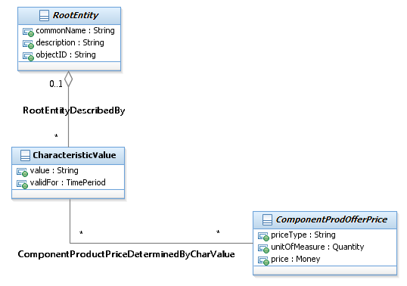
Figure Ch.11 - Characteristic Value and Pricing

Shown in Figure Ch.12 - Content Charging Product Price is an example of viewing of the HD version of 2012, and the price that was determined based on the characteristic values that represent the chosen movie.
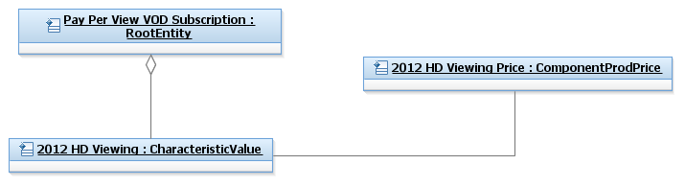
Figure Ch.12 - Content Charging Product Price

Domain Options – Product and/or Resource
The changes is only made to the Characteristic Spec ABE. All other ABEs where this pattern is duplicated are not updated. By promoting the use entities, any entity that does not inherit from the EntitySpecification, or is an entity (RootyEntityType) that does not have a specification, can be related to the use entities.
The choice using this model in the Product and/or Resource domain may be based upon a company’s business model. In the content example presented here, a company may treat each request for content as an order associated with a ProductOffering. Or, a company may treat each request as some form of usage. Or a company may use a hybrid model that combines the treatment of requests.
This model supports all three of these business models, because it can be used for
- Product Spec/Offer Pricing/Charging (as shown in the diagrams in this section)
- Usage Pricing/Charging
- Resource Spec Pricing/Charging.
One other factor needs to be considered when making the choice. The information may have to be duplicated because of application boundaries. A CRM application may need this information as well as Provisioning and Inventory applications.
There are also some application/database implementation considerations
- The use of one set of shared characteristic tables (if the applications are cooperative enough to do this!)
- If the data is only contained in one application then other applications have to request characteristic data from it.
Figure Ch.13 - Content Charging Usage Specification Example shows an example of usage-based pricing/charging.
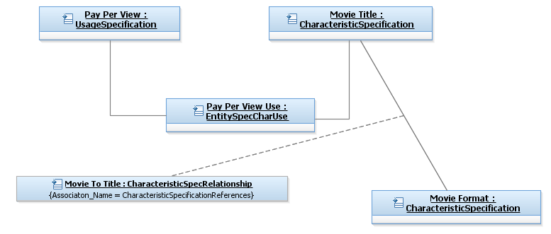
Figure Ch.13 - Content Charging Usage Specification Example
Notice that the only difference between this example and the Product Offering example in Figure 40 is that UsageSpecification is related to the Pay Per View Use instance of EntitySpecCharUse. To handle charging the Usage entity would be related to CharacteristicValue, just as Product was related to CharacteristicValue in the Product domain example in this section.

Policy
This is an abstract class, and is the root of the Policy model. It extends RootEntity to define common attributes, methods, constraints, relationships and behavior that all policy subclasses use and take part in.
The Policy model has two main purposes:
- To represent different types of policies,
- To represent how different constituencies use policy, and
- To represent how policy is used in a managed environment
There are many different types of policies. Policies can control what type of Product should be offered to a particular Market, what type of action should be taken when an SLA condition is violated, when a user’s hard drive should be backed up, or even who should construct and approve configuration changes to a network device.
In general, policy represents a set of goals to be realized when an event occurs. The event itself triggers the evaluation of a set of conditions. If the conditions are met, then a set of actions are directed to be executed.
Addendum 1-POL describes the above three uses in more detail.

Entity Specification Attachment
Entity Specification Attachment represents a group of classes that support an attachment like image, video and document for an entity specification. Figure ESAT.01 shows the UML diagram of the objects in this fragment.
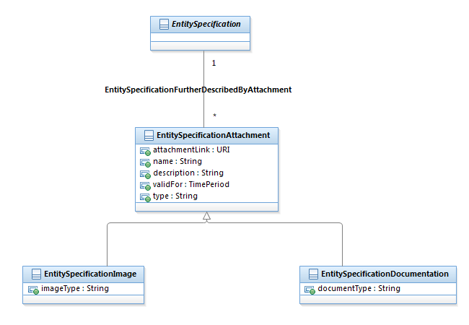
Figure ESAT.01 – View of Entity Specification Attachment

EntitySpecificationAttachment
This is the concrete class representing an attachment like image or a video file for an entity specification. This class is concrete and it can be used without a sub-class. However, one can extend this class to add more specific behavior of an entity attachment. The EntitySpecificationDocumentation and EntitySpecifiationImage are examples of such extension.

EntitySpecificationDocumentation
This is the extended class representing a documentation attachment for an entity specification.

EntitySpecificationImage
This is the extended class representing an image attachment for an entity specification.

Entity Specification Action ABE
Entity Specification Action represents a logical grouping of classes that together support fulfillment of the associated entity. Figure ESAA.01 shows the UML diagram of the objects in this fragment.
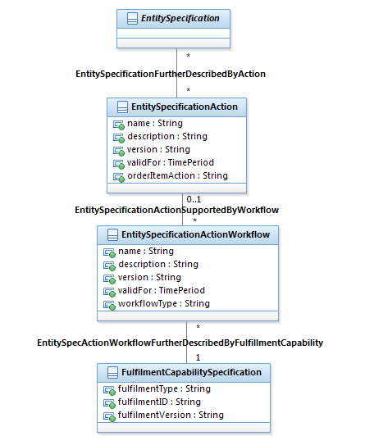

Figure ESAA.01 – View of Entity Specification Action

EntitySpecificationAction
This is the class representing an action like Add, Disconnect and Modify for an entity specification.

EntitySpecificationActionWorkflow
This is the class representing a workflow supporting an action for an entity specification.

External System Capability ABE
External System Capability represents a logical grouping of capabilities that exposed by one system to another system. For example, A catalog modeler can build a product or service by composing these capabilities. Example ESC.02 demonstrates how these capabilities can be used together to build a location API product. These group of logical capabilities are representing a system capability model as seen by its interfaces for given capability so they can facilitate a catalog-driven integration approach. For example, what charging capabilities offered by an online charging system, or what policy model supported by a PCRF system.

ExternalSystemCapability
This is an abstract class, and is the root of the External system capabilities. It extends EntitySpecification to define common attributes, relationships and behavior that all external system capability subclasses use and take part in.
The ExternalSystemCapability model has four main purposes:
- To represent different types of capability,
- To represent which system offers the capability
- To represent how different entity specification like PS, CFSS, RFSS can use these capabilities and
- To represent (optionally) how these capabilities can be accessed by a system like an ordering system thru one or more APIs
There are many different types of capabilities. A system like a charging system can offer multiple capabilities like pre-paid and post-paid charging and a capability can be offered by multiple external system instances.
Figure ESC.01 shows the UML diagram of the objects in this fragment.

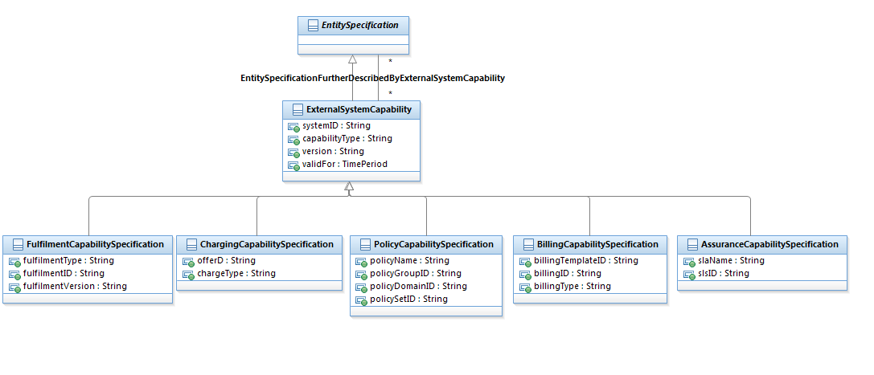
Figure ESC.01 – View of External System Capability

FulfilmentCapabilitySpecification
This is the class representing a fulfilment capability specification as supported by a fulfilment/ordering system

ChargingCapabilitySpecification
This is the class representing a charging capability specification as supported by a charging system like OCS.

BillingCapabilitySpecification
This is the class representing a billing capability specification as supported by a billing system.

PolicyCapabilitySpecification
This is the class representing a policy capability specification as supported by a policy management system like PCRF.

AssuranceCapabilitySpecification
This is the class representing an assurance capability specification as supported by an assurance system.

Example – Location API offer
Figure ESC.02 demonstrates how different external system capabilities together can be used to build a product offer for a location API.
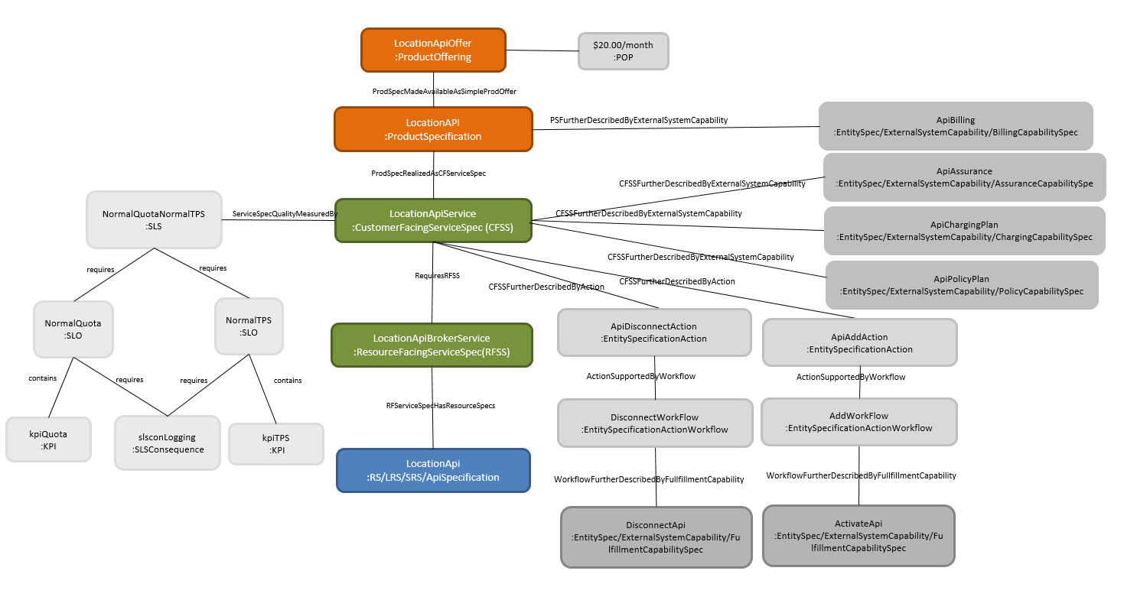
Figure ESC.02 – External System Capabilities to build a location API offering
Table ESC.01 below shows the example characteristics for each object. In this example, a location API product offering is offered based on a Location API product specification with $20 charge per month. The Location API product specification realized as a LocationApiService Customer Facing Service Specification (CFSS). The digital API service quality measured by a service Level Specification with service level objectives and consequence if the expected objectives are not satisfied. The Location API Service CFSS requires an API broker service RFSS which represents an API broker service. This service exposes the API to end user thru external URL as defined in associated ApiSpecification. The API broker service grants access to the (internal) API after authenticating and authorizing a request received thru the (external) API. The ApiSpecification is a software resource specification which includes information for authentication and authorization. In this example, the API is the REST API with JSON format. Allowed entities are the authorized REST resources on this API (location in this example) and allowed operations determine which operation(s) are authorized for this API (GET in this example).
This example, also demonstrates how a catalog-driven system integration can be implemented. A billing capability specification (BCS) represents how a billing system can be accessed to fulfil Location API usage billing. A charging capability specification (CCS) represents how a charging system can be accessed to fulfil Location API charging based on product offering price. An assurance capability specification (ACS) represents how an assurance system can be accessed to fulfil service level specification for Location API CFSS. A fulfilment capability specification (FCS) represents how a fulfilment system (order management) can be guided to execute a fulfilment plan (workflow) for the given product or service. A fulfilment capability specification can be associated with an action defined for product, service or even another capability specification like CSS and PCS. This example only demonstrates actions and workflows associated to Location API CFSS.

Class | Attribute/Characteristics name | value
LocationApiOffer Product Offer | name | LocationAPIOffer
 | description | Location API offer
 | sls | NormalQuotaNormalTPS
LocationAPI  Product Specification | name | locationAPI
 | description | Location API Product Specification
 | family | Digital API
$20/Month  Product Offering Price | chargeType | ctApiMonthly
 | label | Recurring Charge
 | amount | 20
 | ccsCode | ApiChargingPlan
 | classId | default
 | schedule | Monthly
LocationApiService  CFSS | name | LocationDigitalApiCfss
 | description | Location Digital API CFSS
LocationApiBrokerService  RFSS | name | LocationApiBrokerService
 | description | Digital API Broker service
LocationApi  ApiSpecifiction | name | LocationApiRs
 | description | Location API Resource Specification. Location API allow partner to get geographical position of mobile devices owned by given end-customer after obtained authorization of the end-customer over OAuth2.0.
 | apiProtocolType | REST
 | allowedApiEntities | location
 | allowedApiOperations | GET
 | authenticationType | HTTPS/OAuth
 | externalUrl | https://< host:port>/oneapi/location
 | internalUrl | https://< internalhost:port>/oneapi/v2/location
 | externalSchema | https://< host:port>/oneapi/location/schema
 | internalSchema | https://< host:port>/oneapi/v2/location/schema
 | responseTypeFormat | JSON
 | minorVersion | 1
 | majorVersion | 2
 | MinGetLocationAccuracyViolationAction | Reject
 | CoordinateReferenceSystem | WGS84
ApiChargingPlan  ChargingCapabilitySpec (CCS) | name | ApiChargingPlan
 | description | Monthly Charge for API
 | systemID | csWest
 | capabilityType | ctApiMonthlyCharge
 | offerID
 | chargeType | ctApiMonthly
 | chargeFrequency | Monthly
 | currency | USD
 | classID | Default
ApiBilling  BillingCapabilitySpec (BCS) | name | ApiBilling
 | description | Billing template for a digital API service
 | systemID | billngWest
 | capabilityType | apiBillingMonthly
 | billingType | apiMonthlyBilling
 | billingID
 | billingTemplateID | apiMonthlyTemplate
ApiAssurance  AssuranceCapabilitySpec (ACS) | name | ApiAssurance
 | description | Assurance capability for a digital API service
 | systemID | assuranceWest
 | capabilityType | apiAssurance
 | slaName | standard
 | slsID | NormalQuotaNormalTPS
ApiPolicyPlan  PolicyCapabiltySpec (PCS) | name | ApiPolicyPlan
 | description | Policy plan for a digital API service
 | systemID | policyMgrWest
 | capabilityType | apiPolicyPlan
 | policyName | plan_24
 | policyGroupID | 24
 | policyDomainID | apiPolicyDomain1
 | policySetID | ApiUsageruleSet
ApiAddAction  EntitySpecificationAction | name | ApiAddAction
 | description | Add action
 | orderItemAction | Add
ApiDisconnectAction  EntitySpecificationAction | name | ApiDisconnectAction
 | description | Disconnect action
 | orderItemAction | Disconnect
AddWorkflow  EntitySpecificationActionWorkflow | name | AddWorkFlow
 | description | Workflow associated with Add action
 | workflowType | FulfilmentCapabiltySpec
DisconnectWorkflow  EntitySpecificationActionWorkflow | name | DisconnectWorkflow
 | description | Workflow associated with Disconnect action
 | workflowType | FulfilmentCapabiltySpec
ActivateApi  FulfilmentCapabiltySpec (FPS) | name | ActivateApi
 | description | Fulfilment Capability to activate a digital API service
 | systemID | omWest
 | capabilityType | ApiActivation
 | fulfilmentType | workflow
 | fulfilmentID | omWest_ActivateApi
 | fulfilmentVersion | 1.0
DisconnectApi  FulfilmentCapabiltySpec (FPS) | name | DisconnectApi
 | description | Fulfilment Capability to disconnect a digital API service
 | systemID | omWest
 | capabilityType | ApiDeactivation
 | fulfilmentType | workflow
 | fulfilmentID | omWest_disconnectApi
 | fulfilmentVersion | 1.0

References
LIFE | NGOSS Lifecycle Team White Paper, to be published
LIFEPRES | NGOSS Lifecycle Team Dallas TMW 2003 Presentation
ANS T1.253-1999 | American National Standard T1.253, Information Interchange Code Description and Codes for the Identification of Location Entities for the North American Telecommunications System
Concepts and Principles
Location Addendum
Party Addendum
Policy Addendum
Customer Addendum
Product Addendum
Service Overview Addendum
Quality of Service Addendum
Logical and Compound Resource Addendum
Physical Resource Addendum
[ROLEOBJ] | The Role Object (Design) Pattern. Download PDF from  http://www.riehle.org/computer-science-research/1997/plop-1997-role-object.pdf

Administrative Appendix
This Appendix provides additional background material about the TM Forum and this document. In general. Sections may be included or omitted as desired; however, a Document History must always be included.

About this document
This is a TM Forum Guidebook. The guidebook format is used when:
- The document lays out a ‘core’ part of TM Forum’s approach to automating business processes. Such guidebooks would include the Telecom Operations Map and the Technology Integration Map, but not the detailed specifications that are developed in support of the approach.
- Information about TM Forum policy, or goals or programs is provided, such as the Strategic Plan or Operating Plan.
- Information about the marketplace is provided, as in the report on the size of the OSS market.

Document History

Version History

Version | Date | Author | Purpose
0.1 | Sept 2003 | J. Reilly | First Draft
0.2 | Oct 2003 | J. Reilly | Updates based on comments from Paul Levine and John Strassner
0.3 | Oct 2003 | J. Strassner | Additional updates to reflect redesign of Entity Identification
0.4 | Oct 2003 | J. Strassner | Filled in skeleton of complete Addendum
0.5 | Nov 2003 | J. Strassner | Completed Addendum up thru Roles Overview for review
0.6 | Dec 2003 | J. Strassner | Incorporated detailed comments from Dave Raymer, along with additional comments from JohnR and Cliff
0.7 | Dec 2003 | J. Strassner | Finished rest of data dictionary section; one last try to explain UnManagedEntity; additional comments from Cliff
0.8 | Dec 2003 | J. Strassner | Incorporated comments from Dave; final clean-up
0.9 | Jan 2004 | J. Strassner | Final clean-up comments in response to Greg Fiddler
1.0 | Feb 2004 | TMF | Final formatting
1.1 | May 2004 | J. Strassner | Minor update
1.2 | June 2004 | J. Strassner | Included update from John Reilly and Paul Levine
1.3 | July 2004 | J. Strassner | Final revisions for NGOSS 4.5 release
1.4 | August 2004 | C. Faurer | Minor cleanup
1.5 | August 2004 | C. Faurer | Accepted comments from Paul Levine
1.6 | November 2004 | TMF | Minor updates prior to
1.7 |  | TMF | Updated notice statements & doc status
2.0 | March 2008 | John Reilly | Fully develop Characteristic ABE and provide definitions for Entity Identification ABE
2.1 | July 2008 | Tina O’Sullivan | Corrections prior to posting.
2.2 | May 2009 | Alicja Kawecki | Minor updates to reflect TM Forum Approved status
9.0 | January 2010 | John Reilly | Updated to reflect implemented change requests
9.1 | April 2010 | Alicja Kawecki | Minor cosmetic corrections for web posting and ME
9.2 | June 2010 | Alicja Kawecki | Updated Notice
9.3 | October 2010 | Alicja Kawecki | Updated to reflect TM Forum Approved status
9.5 | November  2010 | Sihao Li | Updated with characteristic based pricing model proposed by Huawei
9.6 | March 2011 | Alicja Kawecki | Minor formatting corrections prior to web posting and ME
9.7 | September 2011 | John Reilly | Corrected Figure 35
9.7.1 | November 2013 | Alicja Kawecki | Applied rebranding, updated cover, header, footer & Notice
10.0 | April 2014 | Avi Talmor | Copy of all pertinent information to the model and removal of Business Entity Definition section
10.0.1 | May 2014 | Alicja Kawecki | Updated cover, Notice; minor formatting edits prior to posting
14.5.0 | October 2014 | John Reilly | Updated Characteristic figures based on changes to attribute names.
14.5.1 | March 2015 | Alicja Kawecki | Updated cover, header, footer and Notice to reflect TM Forum Approved status
16.0.0 | May 2016 | John Reilly | Aligned content, including figures, with model
16.0.1 | 26 May 2016 | Alicja Kawecki | Minor cosmetic edits prior to publication for Fx16
16.5.0 | October 2016 | Kamal Maghsoudlou | Added Entity Specification Action, Entity Specification Attachment and External System Capability Fragments
16.5.1 | 21 November 2016 | Alicja Kawecki | Updated cover, minor cosmetic corrections prior to publication for Fx16.5

Release History

Release Number | Date Modified | Modified by: | Description of changes
8.0 | 7/July/2008 | John Reilly | Fully develop Characteristic ABE and provide definitions for Entity Identification ABE
9.0 | January 2010 | John Reilly | Updated to reflect implemented change requests
9.5 | November  2010 | Sihao Li | Updated with characteristic based pricing model
9.5 | September 2011 | John Reilly / Josh Salomon | Corrected Figure 35
10.0 | April 2014 | Avi Talmor | Copy of all pertinent information to the model and removal of Business Entity Definition section
14.5.0 | October 2014 | John Reilly | Updated Characteristic figures based on changes to attribute names.
16.0.0 | May 2016 | John Reilly | Aligned content, including figures, with model
16.0.1 | 26 May 2016 | Alicja Kawecki | Minor cosmetic edits prior to publication for Fx16
16.5.0 | October 2016 | Kamal Maghsoudlou | Added Entity Specification Action, Entity Specification Attachment and External System Capability Fragments

Acknowledgments
This document was prepared by the members of the TM Forum Information Framework (SID) team.
The Shared Information/Data Model is a genuinely collaborative effort. The TM Forum would like to thank the following people for contributing their time and expertise to the production of this document. It is just not possible to recognize all the organizations and individuals that have contributed or influenced the introduction. We apologize to any person or organization we inadvertently missed in these acknowledgments.
Key individuals that reviewed, provided input, managed, and determined how to utilize inputs coming from all over the world, and really made this document happen were:

Name | Affiliation
Cliff Faurer | TM Forum
Ed Grossman | Independent
Enrico Grosso | Telecom Italia
Chris Hartley | Telstra
Paul Levine | Telcordia
Dave Raymer | Motorola
John Reilly | MetaSolv Software
Wayne Sigley | Telstra
John Strassner | Intelliden (editor)
Fabrizio Bobbio | Telecom Italia
Francis Anderson | IBM
Lutz Bettge | T-Systems
Josh Salomon | Amdocs
John Giles | Telstra
mTOP-SM Team | TM Forum
Sihao Li | Huawei

